CPSC 4317: Computer Networks
Homework 5
Due 10:00am. Nov. 8, 2024 (Friday)

Name: ____Andrew Kalathra___

LUID: ______L20498001_____

Date: _____10/08/2024_____

22.19 When reassembling fragments, how does IP software know whether incoming fragments belong to the same datagram? (10 points)

- The IPv4 datagram header contains a few fields, of which include the identification field, flags field, and fragment offset field.
- The field tells if it is a fragment.
- The identification field is same across all the fragments to denote they all form the message.
- The fragment offset field tells the order the fragments should be place in.

23.1 When a router uses a forwarding table to look up a next-hop address, the result is an IP address. What must happen before the datagram can be sent? (10 points)

- From the forwarding table, the router must know where to send the datagram (forwarding).
- The router uses the masks defined in the table to check for a match using a bitwise AND operations. If the resulting address is equal to the destination address saved on the forwarding table, then the datagram is sent to the Next Hop as defined by that entry in the forwarding table.

23.6 How does a computer know whether an arriving frame contains an IP datagram or an ARP message? (10 points)

- The Type field in the frame header specifies that the frame contains an ARP message or an IP datagram by a code. Ethernet uses type field 0x806 to denote an ARP sequence. On the other hand, 0x800 denotes an IP datagram.

23.9 When does Algorithm 23.1 create a new entry in an ARP cache (10 points)
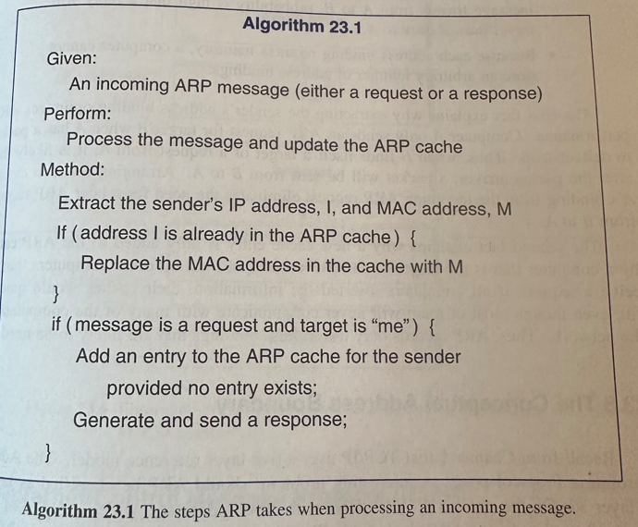

- If a message is a request and the target is my computer, and an entry IP address does not exist, then an entry IP address is added.
- This is because IP addresses can change, but MAC addresses cannot. A person can change their IP address easily, but a MAC address is tied to a computer. As such, the router keeps track of IP addresses and reassigns MAC addresses to IP addresses. If a very new IP address is entered, then the router must add it to the cache. However, if a new MAC address has entered, it will be assigned an open IP address from the network.

23.12 If a routing loop exists, which ICMP error message will be sent? Explain the process. (10 points)

- ICMP error message 5 will be sent as it is of the Redirect type, which tells the host to change the route of transmission. This will hopefully avoid the routing loop.
- If the loop makes the destination unreachable, however, then the ICMP error message 3 will be sent as it is of the Destination Unreachable type, which tells the host that the Datagram could not be delivered.

23.15 Given an Ethernet frame, what fields does a host need to examine to determine whether the frame contains an ICMP message? (10 points)

- An ethernet frame has the IP datagram as its payload. As such, analyzing the frame header first to ensure an IP Datagram is primarily needed.
- Following this, the IP Datagram may contain an ICMP message as its payload. To ensure this is the case, the IP Header must be analyzed to see if it has the protocol number of 1, which denotes a ICMP payload.

25.2 List the features of TCP. (10 points)

- Connection Oriented – Prior to any packages being sent, a connection must first be established. This makes TCP reliable.
- Point-to-point Communication – Going more specific than IP, TCP focuses on the specific port that the packet must be delivered to. This helps the right application receive the right information.
- Complete Reliability – As long as a connection is formed, TCP ensures that packets are delivered completely and in order.
- Full Duplex Communication – Both parties can send and receive. This does not require multiple connections to be formed, but the receiver can become a sender, and vice versa.

25.10 How does TCP handle packet loss? (10 points)

- Using positive ACK’s (positive Acknowledgement control messages), the receiver can notify the sender of the last packet received.
- When the receiver get’s this positive ACK, it will then resend the lost packet. This makes TCP reliable due to redundancy for lost packets.

25.12 How does the TCP compute timeout for retransmission? (10 points)

- After a packet is sent, a timer is set up. If an ACK message is not received after the timer is up, the packet is retransmitted.
- Calculating this timeout is tricky, as having a fixed timeout is not applicable. If a timeout that is too small is set for a technology that naturally takes a longer period of time to transmit, multiple unnecessary packets will be sent. On the other hand, setting a timeout for too long will cause faster transmission technology to take longer to realize if a packet is lost.
- As such, an adaptive approach is taken. The sender can time how long it takes for a packet to send and then receive an ACK. This time period is called the RTT (Round Trip Time). Using multiple packets over time, the sender can calculate the variance (how much change) and mean (average) of the RTT, which can then be plugged into a statistical function to produce a weighted average, which then becomes our timeout.

25.16 What problem in a network causes TCP to reduce its window size temporarily? (10 points)

- Congestion of the network will cause packets to be delivered slower. This, in turn, will tell the congestion window size to decrease.
- Alongside this, the receiver advertisement will also tell how many packets are allowed to be sent in a certain time frame, aka the window.
- The variation of the window size can be summarized by this formula:
Allowed_window = min(receiver_advertisement, congestion_window)
  - This means the allowed window size we be the lowest between the receiver advertisement or the congestion window.

How to Turn In:

Only softcopy is required.
- Please use the blackboard system to turn in the softcopy of all your solutions.

